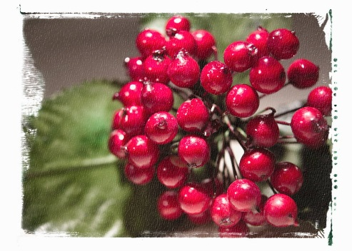
Science of Christmas Quiz

Name Form

Answer all the questions below. You will definitely need books, Google and some grown up help. Lots of this info can also be found at the Science or Natural History Museums.

When you’re done either email it in at kcritchley@nautical.lambeth.sch.uk OR hand it in in person to me in Rm111 before the end of the first day back at school 6th January. Winners announced shortly after! Good luck!

- As Santa flies around the planet what force stops his sleigh from being lost to space?

- In the Christmas story, Mary is described as being a virgin. Virgin births are possible due to the modern science of IVF, what do the initials IVF stand for?

- It has been worked out that on Christmas Eve, Santa has 32 hours to deliver all the presents. Give a reason why he has longer than a day.

- Assuming one mince pie (250kcal) and one 50ml glass of sherry per household (58kcal). How many calories would Santa consume if he had this at every house in London?
SHOW ALL YOUR WORKING AND RESEARCH

- Which Christmas has the Latin name Phoradendron and is poisonous?

- One of the gifts the 3 Wise Men brought to the baby Jesus was gold. What is the chemical symbol for the element gold?

- Which gas is most likely to make up the majority of the Star of Bethlehem?

- Reindeer are ruminants (just like cows). How many chambers do their stomachs have?

- A Christmas candle releases energy as both heat and light but what form was the energy in originally, before the candle was lit?

- Currants, raisins and sultanas are dried fruits often found in Christmas cakes. What fruit were they before they were dried?

- Santa Claus, as well as all real-bearded people, have natural beards that are chemically of what material or substance?

- Brussel sprouts contain a chemical called Sulforaphane which has the formula C6H11NOS2. How many different elements are there in Sulforaphane?

- In which part of the plant does a Christmas tree (fir tree) store its seeds?

- Mary travelled to Bethlehem on which animal, a species that is closely related to a horse? Give the Latin or Greek name

- In the song ‘The 12 days of Christmas’, how many different species of birds are mentioned?

- Which metallic element is mentioned in the carol ‘In the bleak midwinter’?

- There is only one plant mentioned in the song ‘The 12 days of Christmas’, what fruit grows on it?

- Find out how deep the layer of reindeer poop covering the earth would be on Christmas day. Bonus points for trying to calculate this yourself.

- Imagine there are 3.6 billion children on earth and40% do not receive gifts while the other 60% receive one gift each. Half the gifts delivered weight two kilos. Half weigh 1.5kg. What is the total mass of gifts delivered?

- What colour is snow?

